The Science of Creativity and Learning
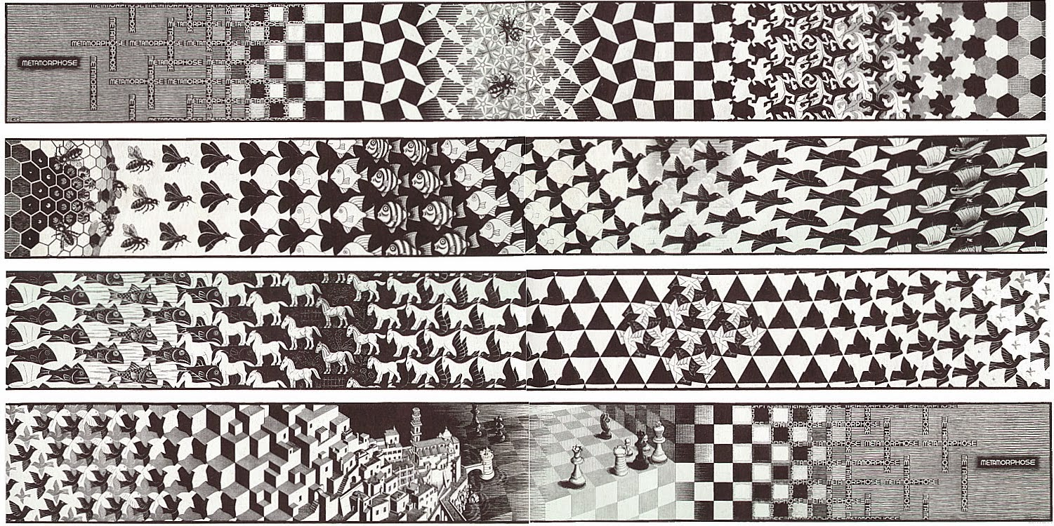
Please use these email addresses, NOT d2l
Jeff Leake, M.F.A., Instructor; jleake@pdx.edu
Bill Griesar, Ph.D., Instructor; griesar@pdx.edu
Peer Mentor: Lidia Echeverria-Garcia elidia@pdx.edu

OFFICE HOURS: TBA

WINTER TERM: January 6 – March 21, T-TH, 10:00-11:50

ART SUPPLIES (required): Sketchbook (standard 11” x 14” drawing, 80-pound weight paper), colored pencils (basic set, 12 assorted colors), graphite drawing pencils, white plastic eraser, Assorted pipe cleaners.

NOTE: You will need a College Creative License (student museum pass) for the Portland Art Museum $20

GOAL OF THE COURSE:
Creativity is one of the most complex and uniquely human behaviors that we exhibit. By exploring the biological drives behind our aesthetic experiences, and by examining physically what happens when we engage in creative activities, we can learn a great deal about how we perceive and interact with the world around us.
In this course we will directly examine how vision, sound, touch and other stimuli are essential for perceptual experience. We will explore the surprising history of anatomical study, the depiction of brains and bodies in medical texts and art, and the neurobiological mechanisms that generate behavior, and explore how stimuli affect the nervous system, driving conscious and unconscious responses that drive us to create and learn.
In addition, we will examine how our critical, adaptive, neurobiological networks develop, operate, and inevitably decay. How does decay, and also drug action, provoke change in what we see, hear, taste and feel? How does knowledge of neuroanatomy allow us to attempt structural replacement of our eyes, ears, and limbs? What does it ultimately mean to be information processing networks of neurons and also new machines? Who benefits from these technologies, and how does our evolving scientific understanding affect ethical decision making and creative responses to perceived aspects of our world?

GRADES: Grades are based on the following point scale: 90 points and above = A; 80 – 89 points = B; 70 – 79 points = C; 60 – 69 points = D; 59 points or below = F. An A or B is an ABOVE AVERAGE grade, a C is AVERAGE, and a D is BELOW AVERAGE. You can earn points in this class in the following ways…

**** DEADLINES ARE IMPORTANT: LATE WORK RECEIVES NO CREDIT. ****

READING RESPONSES (35 points)
Reading Response 1: (5 points)
Reading Response 2: (5 points)
Reading Response 3: (5 points)
Reading Response 4: (5 points)
Reading Response 5: (5 points)
Reading Response 6: (5 points)
Reading Response 7: (5 points)

ART PROJECTS (25 points)
Art Project 1: Brain poem (5 points)

Art Project 2: Neuron model (5 points)
Art Project 3: Inverted drawing (5 points)
Art Project 4: Mirror drawing (5 points)

MUSEUM BLOG (10 points)

MENTOR SESSIONS (10 POINTS)

E-PORTFOLIO (10 POINTS)
Pebble Pad Portfolio

FINAL ART PROJECT (10 points)
Final Art Project: Illusion project

ACADEMIC HONESTY: Any evidence of cheating or plagiarism will lead to serious academic consequences, including possible failure of the course and/or dismissal from school. Plagiarism is also a violation of the PSU Code of Student Conduct. For more information see: http://www.pdx.edu/dos/psu-student-code-conduct

STUDENTS WITH DISABILITIES: If you are a student with a documented disability
and registered with the Disability Resource Center (DRC), please contact the instructor immediately to facilitate arranging academic accommodations. If you have a disability and have not yet registered with the DRC, please contact the DRC immediately.

NOTE: Incompletes are rarely given, and are based on criteria described in
the university catalog. Incompletes are not appropriate when less than ¾’s of the course work has been scored. No incomplete will be assigned without a written formal agreement and timeline related to course completion.

EXCUSES: Life has ups and downs, and everyone struggles sometimes with family, work, and other personal concerns and commitments. However, unless there is a serious, unexpected, sudden, and significant emergency, please do not petition for special treatment regarding deadlines for projects, quizzes, or exams. I am required to treat all students fairly, and that means each of you must think ahead and plan for when assignments
are due. Everyone is subject to the same course expectations …

THE CLASSES
WEEK ONE: January 7 – January 9
INTRODUCTIONS: UNST goals, what does perception mean? History & philosophy
ASSIGN: Museum Blog (due Week 9)

READ: Patricia S Churchland, The Impact of Neuroscience on Philosophy
Mentor Session:
WEEK TWO: January 14 – January 16

SENSORY DETECTION: Neurons carry information-rich electrical messages, and communicate with each other by releasing chemical messengers (neurotransmitters)
What sort of sensory detection machinery do you have? How is detected information transferred to neural networks for further processing and response?
READ: Semir Zeki, The Neural Correlates of Beauty
DUE:
READING RESPONSE 1 DUE (Tuesday 1/14): Patricia S Churchland, The Impact of Neuroscience on Philosophy
OUTREACH OPPORTUNITIES:
JAN 11 Don’t Shoot Portland @ the Portland Art Museum
JAN 15-18 Astoria Outreach

WEEK THREE: January 21 – January 23
NEUROESTHETICS: The first part, Semir Zeki
Introduction to Pebble Pad
READ: This Is Your Brain on Art
ART PROJECT 1: Brain poem (Due Tuesday Week Four)
DUE:
READING RESPONSE 2 DUE (Tuesday 1/28): Semir Zeki, The Neural Correlates of Beauty

WEEK FOUR: January 28 – January 30
NEUROESTHETICS: The second part, V.S. Ramachandran
READ: TBA

ART PROJECT 2: Neuron Model (Due Week Five 2/4)
DUE:
READING RESPONSE 3 DUE (Tuesday 1/28): This Is Your Brain on Art
OUTREACH OPPORTUNITIES:
JAN 28 Coffee Creek Correctional Facility

WEEK FIVE: February 4 – February 6

GESTALT THEORY: The principles of design, Contemporary Gestalt and neuroscience.
ART PROJECT 3: Inverted drawing (Due Week Six 2/11)
DUE:
ART PROJECT 2 DUE: Neuron model (Tuesday 2/4)
READING RESPONSE 3 DUE (Tuesday 2/4): TBA
OUTREACH OPPORTUNITIES:
2/7-2/9 Apilleras @ P:ear

WEEK SIX: February 11 – February 13
MUSEUM VISIT: Thursday February 13th
READ: Magic and the Brain: Teller Reveals the Neuroscience of Illusion
DUE:
ART PROJECT 3 DUE: Inverted drawing (Due Tuesday 2/11)

WEEK SEVEN: February 18 – No Class February 20
ASSIGN: Illusion project (due week 10)
ART PROJECT 4: Mirror drawing (Due Week Eight 2/25)
DUE:
READING RESPONSE 5 DUE (Tuesday 2/18): Magic and the Brain: Teller Reveals the Neuroscience of Illusion

OUTREACH OPPORTUNITIES:
2/19-2/21 Grants Pass

WEEK EIGHT: February 25 – February 27
ILLUSIONS: Discover how illusions fool our perceptual systems.
Sign up for Illusion presentation times
READ: Hallucinations by Oliver Sachs, chapter four
DUE:
ART PROJECT 3 DUE: Mirror drawing (Tuesday 2/27)

WEEK NINE: March 3 – March 5
HALLUCINATIONS & Synesthesia: The how and why of hallucinations, Hold some brains!

ART PROJECT 5: Exquisite corpse drawing (Due Week Ten 3/13)
READ: Hearing Colors, Tasting Shapes
DUE:
ART PROJECT 4 DUE: Mirror drawing (Tuesday 3/3)
READING RESPONSE 6 DUE (Tuesday 3/3): Hallucinations by Oliver Sachs, chapter four

Museum blog (Thursday 3/5)

WEEK TEN: March 10 – March 12
ILLUSION PRESENTATIONS (Tuesday 3/10, Thursday 3/12)
DUE:
ART PROJECT 5 DUE: Exquisite corpse drawing (Tuesday 3/10)
DUE: Museum Blog (Tuesday 3/10)
READING RESPONSE 7 DUE (Tuesday 3/10): Hearing Colors, Tasting Shapes

E-Portfolio Due (Thursday 3/12)
FINAL PROJECT: Gallery Walk On Thursday March 19

A REMINDER: Life has ups and downs, and everyone struggles sometimes with family, work, and other personal concerns and commitments. However, unless there is a serious, unexpected, sudden, documented, significant emergency, please do not petition for special treatment regarding deadlines for projects.

Once again, I am required to treat all students fairly, and consistently, and that means each one of you must think ahead and plan for when assignments are due. Everyone is subject to the same course expectations.

Note that sometimes, for a myriad of reasons, life intervenes to create ongoing difficulties with class attendance, and meeting academic requirements. In these cases, it's often best to withdraw from the course, and perhaps re-enroll at a less stressful time...

