Pipe Cleaner Neurons
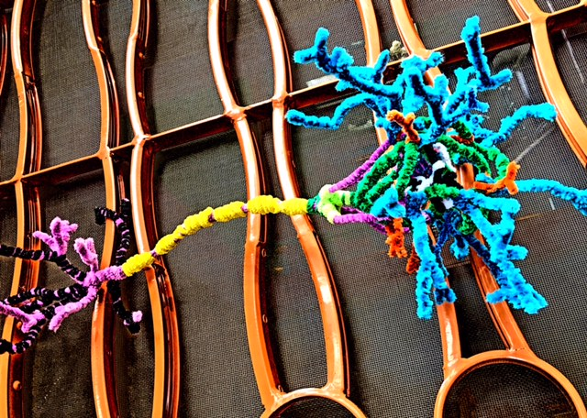

Your brain, like all body tissues, is made of cells.
But brain cells (called neurons) often look very different from skin, or liver cells - they are remarkably diverse in shape and size. How something is structured determines what it can do - and neurons can do many things!

Most neurons do have a few standard parts that you can create by bending, twisting and linking up pipe cleaners…

Cell body, or soma: typically a spherical structure (though sometimes it’s shaped like a 3D pyramid!). The cell body is home to the nucleus, which contains DNA - the genetic instructions for building the entire neuron!

Dendrites: the input end of neurons, with multiple, cell membrane-bound branches where other neurons deliver excititory (fire!) and inhibitory (stop!) messages, by releasing chemicals called neurotransmitters…

Axon: output from neurons (in the form of electric current!) travels away from the cell body along this wire like projection, which can be short - or extremely long. Some wires travel from your toes all the way to the
base of your brain - that’s one long neuron!

Ask about other parts of neurons you can make: the nucleus in the cell body, for example, filled with twisted pipe cleaner DNA, or myelin, supportive insulation for the axon wires that makes electric messages travel faster…

