Sheep Brain Dissection Guide
MESA and NWNoggin summer Neuroscience program
July 30, 2015

Through this guide, you will find images and tools to help you identify the structure and remember the function of many brain areas. Make sure to ask questions, have fun, and only slice the sheep brain (not your partner)!

With a partner, you will share 1 sheep brain and work your way through this dissection guide. Identify the structures that we have discussed during the program and answer the questions about the function of these regions.

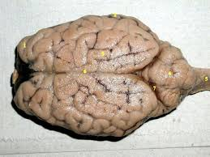
On the outside surface of the brain, notice the ridges and grooves. The ridges are called gyri (singular, gyrus) and the grooves are called sulci (singular, sulcus). Not all animals have gyri and sulci.

Can you think of one animal other than the sheep that has sulci and gyri?

Can you think of one animal that does not have sulci and gyri?
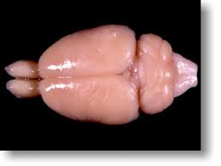

The cerebrum is made of two hemispheres. Identify the left and right hemispheres.

The brain has two appearances, white and gray. The gray matter contains cell bodies and dendrites and the white matter contains axons. What surrounds and insulates the axon?

Based on this information, is the outside of the brain white matter or gray matter?

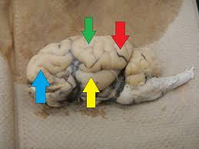
The sheep brain and the human brain are different in the location of the different lobes. Identify the 4 lobes that are visible on the outside of the brain.

Blue arrow:
Green arrow:
Red arrow:
Yellow arrow:

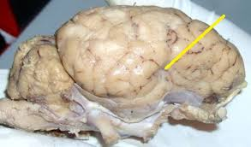
Try to gently separate the temporal lobe from the frontal lobe and observe the structure. What is this structure called?

Find the region of the sheep brain that has more sulci and gyri. This is called the cerebellum.

What is one function of the cerebellum?

On the underside of the cerebellum is a structure called the brainstem. Is the brainstem white matter or gray matter?
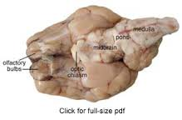

Identify the brainstem. The brainstem is separated into 3 regions: medulla, pons, and midbrain. The brainstem is continuous with the spinal cord.

Also on the underside of the brain, find the white “X” looking structure. This structure is important for vision.

What is this structure called?

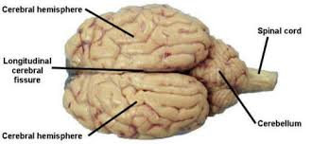

Very carefully, using the scalpel, make an incision through the longitudinal cerebral fissure, along the black dashed line. This will separate the brain into the two hemispheres.
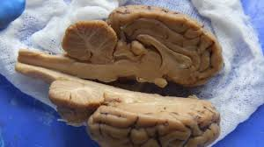
After this incision, your brain should look like this:

On the inside view of the brain, identify the corpus callosum. What type of matter is the corpus callosum made of? What does the corpus callosum do?

Above the corpus callosum is another lobe. What lobe is this and can you name one network that this lobe participates in?

Identify the brainstem and the cerebellum in this view.

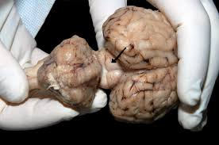
Separate the cerebellum and the cerebrum on one half of the brain. There are two little bumps between these surfaces. The one closer to the cerebrum is the superior colliculus. What system is this structure important for?

Make an incision on the one half of the brain (going the short way) through the temporal lobe. Try to find a region that appears similar to the image below (but only on half of the brain).

See if you can find the region of the brain that looks like a small C or a squiggle. This is a region important for memory. What is this region called?

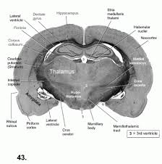
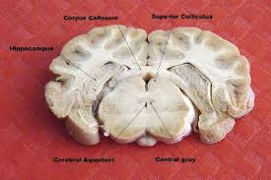

A bit more difficult to identify is the amygdala. See if you can make an incision with half of the brain to appear similar to the image below.

Name one function of the amygdala.

