The Neurolinguistics Lab in PSU’s Department of Speech & Hearing Sciences needs adults with a history of
HSRRC Proposal #132480 Expiration date: Feb 21, 2017

How do you read sentences?
CLOSED HEAD INJURY OR CONCUSSION
for a study of the effects of cognition & mood on sentence comprehension.
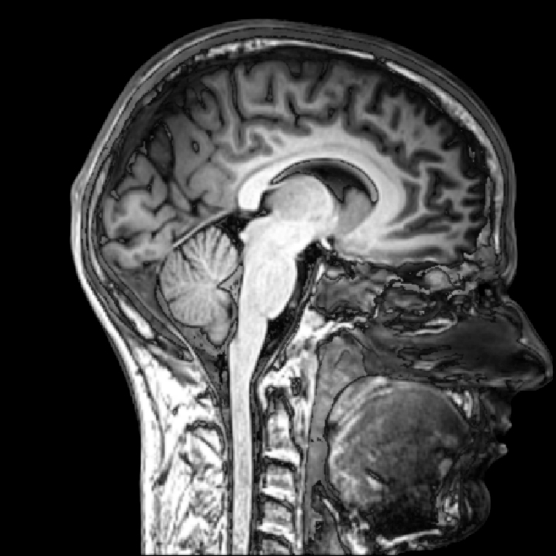
Receive $40 for participation!

Participants must be…
- Native English speakers (or have native speaker-level English proficiency)
- Age 18+
- No history of neurological illness other than closed head injury (such as stroke or MS)

To learn more, contact: The Neurolinguistics Lab
at 503-725-3595 or keydel@pdx.edu

Mood & Sentence Comprehension Study
(503)725-3595
keydel@pdx.edu

Mood & Sentence Comprehension Study
(503)725-3595
keydel@pdx.edu

Mood & Sentence Comprehension Study
(503)725-3595
keydel@pdx.edu

Mood & Sentence Comprehension Study
(503)725-3595
keydel@pdx.edu

Mood & Sentence Comprehension Study
(503)725-3595
keydel@pdx.edu

Mood & Sentence Comprehension Study
(503)725-3595
keydel@pdx.edu

Mood & Sentence Comprehension Study
(503)725-3595
keydel@pdx.edu

Mood & Sentence Comprehension Study
(503)725-3595
keydel@pdx.edu

