ZOOM Sequence Activity
Materials: Zoom by Istvan Banyai
The 25 images are also available through various websites for free (will need to print)
Goal: To properly order the sequence of images
Describe the concept of Structure = Function, the concept of a sequence.
This could be demonstrated with the structure of a neuron. After reviewing the parts of a neuron, consider whether or not an action potential could fire if the axon was out of sequence, attached to the end of a dendrite. Changing the structure changes the function. A series that is out of order may not function.
These concepts could also be demonstrated with networks like the default mode network, the visual system, etc.
Time: ~20min (review, instructions, and activity)
Participants: Up to 25
Instructions:
Before passing out one image to each participant, instruct everyone that they may only look at their own images.
After briefly studying the picture, participants are to get up (with their picture), move around, and through verbal communication only, describe their images with others participants.
The goal is for the group to figure out the sequence of the pictures. Participants with similarly described images should stick with each other and continue to search for others.
When everyone agrees on the order, they are to link up side-by-side and hold out the images. Teachers can judge whether or not the images were correctly sequenced.
Have everyone line up their images on a table or the floor to see the entire sequence! Even though they each only had one aspect of the larger sequence, if one is out of order the entire series is affected.
See pictures of the activity in action below!

Additional activity: Create a sequence
Materials: Paper, drawing supplies
Goal: Reinforce the previous concepts with the creation of unique sequences
Time: ~15
Instructions:
After completing the Zoom Sequence Activity and reviewing the concepts covered, groups could be formed and tasked with coming up with their own sequence (ex. a seed, a sprout, a sunflower, a bag of sunflower seeds, a baseball player, a stadium).
Groups could be instructed to come up with a neuroscience themed sequence as well (ex. a tack, a foot stepping on a tack, signal from toe to spine, signal from spine to toe, pulling back foot, a person saying “ouch!”).
Once decided and the sequence drawn on different sheets, mix them up and switch with another group. Repeat the Zoom activity with the created sequences in the smaller groups.

Pictures from the NW Noggin 2015 Summer Outreach Program with the MESA program at WSU-V

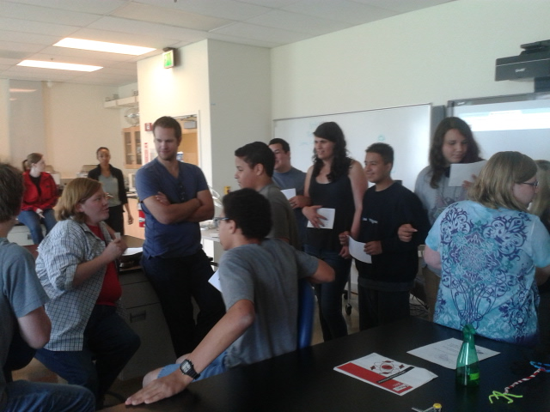
Teamwork and communication in action! Participants talking and starting to link up.
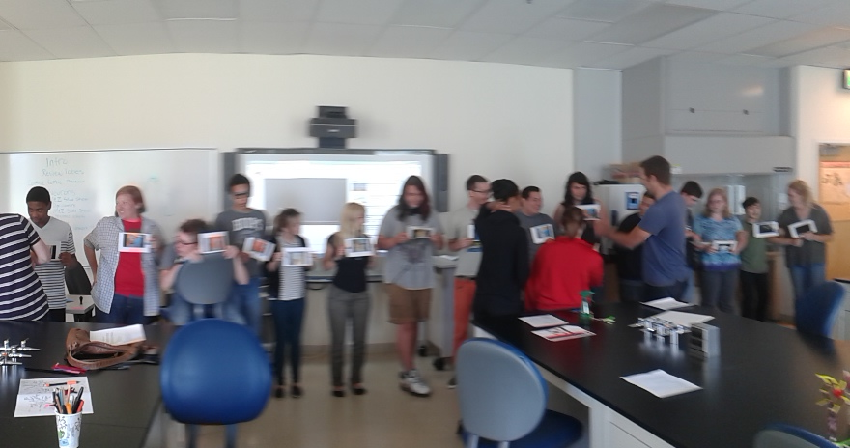
Judges, did they do it? The sequence doesn’t necessarily need a key, teachers will likely be able to tell if everyone was successful.

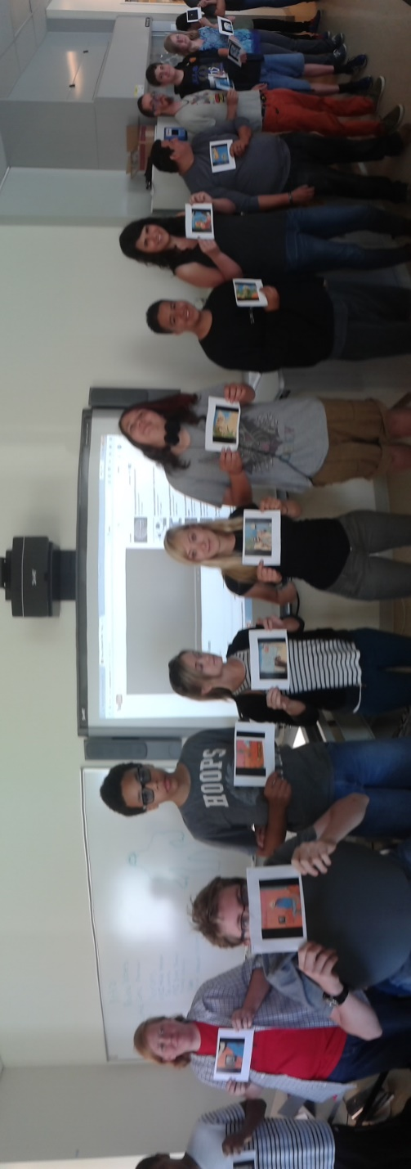
SUCCESS!!
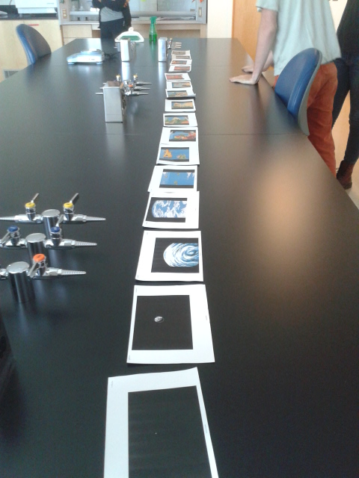
The sequence lined up for everyone to see.

Be sure to share any comments and pictures of your own!

nwnoggin.org

